Adaptive Wavelet-Based Image Compression Using Bayesian Thresholding and Run-Length Encoding

Abstract
Efficient image compression is essential for reducing storage requirements and enabling fast transmission in modern multimedia systems. This paper presents a hybrid image compression framework integrating the Discrete Wavelet Transform (DWT), Bayesian thresholding (Bayes Shrink), variance-driven adaptive quantization, and Run-Length Encoding (RLE).
The proposed method leverages multi-resolution analysis to separate structural and detail components of the image. Bayesian thresholding is applied to suppress noise and increase sparsity in wavelet coefficients. A variance-based quantization strategy is then applied at the subband level, where quantization strength is adjusted according to the statistical properties of each subband. The resulting sparse representation is encoded using RLE, and compression performance is estimated using entropy-based bit calculations..

Keywords
Image Compression, Discrete Wavelet Transform, Bayes Shrink, Adaptive Quantization, Run-Length Encoding, PSNR, SSIM

I. Introduction
The rapid expansion of digital multimedia applications has significantly increased the demand for efficient image compression techniques. High-resolution images require large storage space and transmission bandwidth, making compression

essential for practical applications such as cloud storage, surveillance, and mobile imaging.
Conventional compression methods such as JPEG rely on the Discrete Cosine Transform (DCT) applied to fixed-size blocks. While computationally efficient, this approach introduces blocking artifacts and fails to adapt to spatial variations in image content. Additionally, uniform quantization schemes used in such methods do not effectively utilize the statistical characteristics of image regions.
To address these limitations, this paper proposes a wavelet-based compression framework that operates on the entire image using multi-resolution decomposition. By combining Bayesian thresholding and variance-based quantization, the proposed method aims to reduce redundancy while preserving perceptually important features.
The main contributions of this work include:
- A unified DWT-based compression pipeline with integrated Bayesian thresholding
- Subband-level variance-driven adaptive quantization
- Entropy-based compression estimation using Run-Length Encoding
- Adaptive step-size selection for balancing compression and quality

II. Related Work

A. Transform-Based Compression
JPEG uses the Discrete Cosine Transform for frequency-domain representation but suffers from blocking artifacts at high compression levels. JPEG2000 introduced the Discrete Wavelet Transform, enabling multi-resolution representation and improved visual quality.

B. Adaptive Quantization
Adaptive quantization techniques aim to allocate bits efficiently based on image characteristics. Modern approaches adjust quantization parameters according to spatial activity. This work adopts a variance-driven approach applied at the subband level.

C. Thresholding and Encoding
Bayesian thresholding methods such as Bayes Shrink effectively remove noise in wavelet coefficients. Entropy encoding techniques such as Run-Length Encoding are commonly used to compress sparse data representations.

III. Proposed Methodology

A. System Overview
The proposed compression framework consists of the following stages:
- Multi-level wavelet decomposition using DWT
- Bayesian thresholding of detail coefficients
- Subband-level adaptive quantization
- Run-Length Encoding with entropy-based size estimation

B. Discrete Wavelet Transform
The input image is decomposed into multiple levels using 2D DWT, producing approximation (LL) and detail (LH, HL, HH) subbands. This representation enables separation of low-frequency structural information from high-frequency details.

C. Bayesian Thresholding (Bayes Shrink)
Noise variance is estimated from each detail subband using robust median estimation. The threshold is computed as:
T=σn2σxT = \frac{\sigma_n^2}{\sigma_x}T=σx​σn2​​
where σn\sigma_nσn​ represents noise variance and σx\sigma_xσx​ represents signal variance.
Soft thresholding is applied to suppress coefficients with small magnitudes, increasing sparsity and reducing noise while preserving significant structural information.

D. Subband-Level Adaptive Quantization
After thresholding, quantization is applied to wavelet coefficients. Unlike local or block-based quantization, the proposed method computes variance at the subband level.
The quantization step size is defined as:
Q=step×(1+variance)Q = \text{step} \times (1 + \text{variance})Q=step×(1+variance)
where:
- step is a global base step size
- variance is the variance of the entire subband
This design increases the quantization step for high-variance subbands, enabling stronger compression while relying on prior thresholding to preserve important coefficients.
Quantization is performed using rounding, and reconstruction uses the base step size for simplicity and computational efficiency.

E. Run-Length Encoding and Compression Estimation
The quantized coefficients are flattened into a one-dimensional sequence and encoded using Run-Length Encoding. Since thresholding produces many zero-valued coefficients, RLE efficiently compresses long sequences.
Instead of generating an actual compressed bitstream, the compressed size is estimated using entropy-based calculations:Symbol entropy based on frequency distribution
- Logarithmic estimation of run-length encoding cost
- This provides an approximate measure of compression efficiency.

F. Adaptive Step-Size Selection
To balance compression ratio and image quality, an adaptive step-size search mechanism is employed. The algorithm evaluates multiple step values and selects the one that satisfies predefined constraints on PSNR and compression ratio.
If no candidate satisfies the constraints, a scoring function is used to select the best trade-off between distortion and compression efficiency

IV. Experimental Setup

A. Dataset
Experiments are conducted on standard grayscale images including Cameraman, Coins, and Moon, resized to multiple resolutions.

B. Evaluation Metrics
The following metrics are used:
- Mean Squared Error (MSE)
- Root Mean Squared Error (RMSE)
- Peak Signal-to-Noise Ratio (PSNR)
- Structural Similarity Index (SSIM)
- Bits Per Pixel (BPP)
- Compression Ratio (CR)

V. Results and Discussion
The proposed method demonstrates strong performance across multiple wavelets, decomposition levels, and image sizes.
Key observations:
- Higher PSNR and SSIM compared to JPEG at similar compression ratios
- Reduced visual artifacts due to wavelet-based processing
- Effective sparsity generation through Bayesian thresholding
- Adaptive step selection improves rate–distortion balance
The rate–distortion curves show that the proposed method achieves a favorable trade-off between compression ratio and reconstruction quality.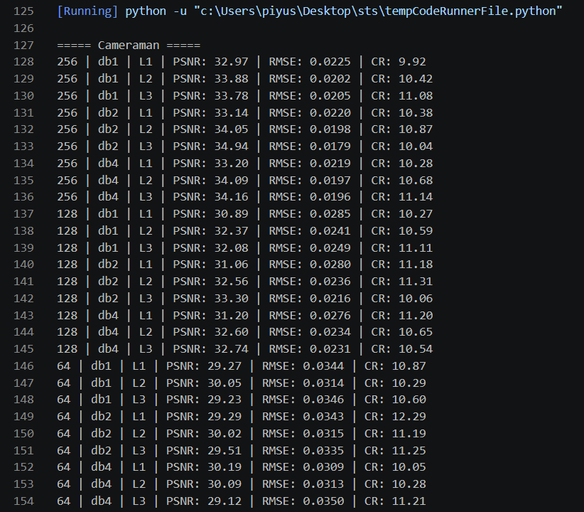
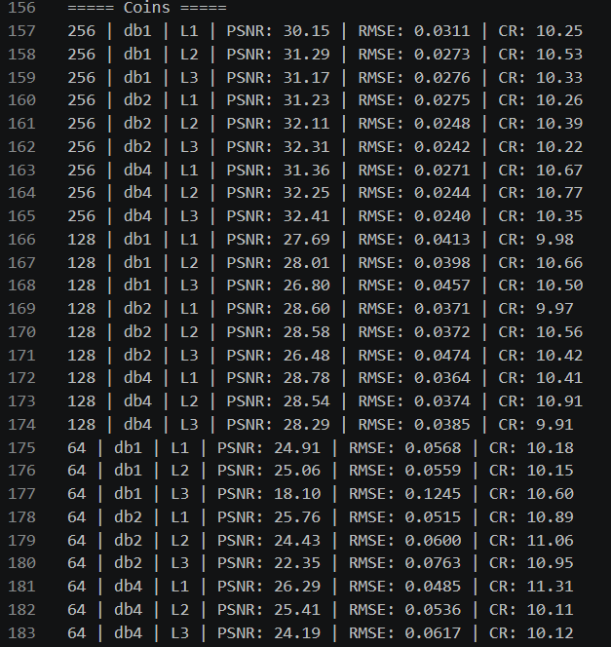
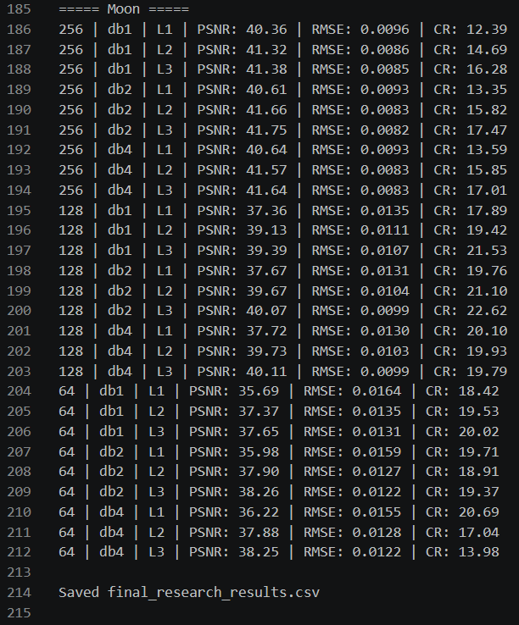
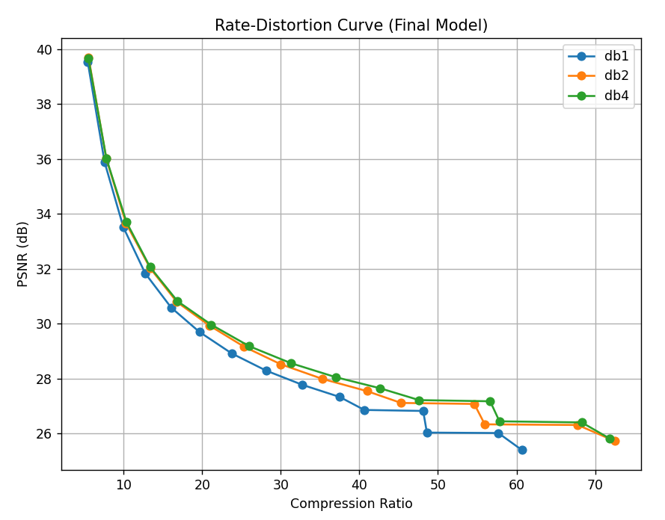
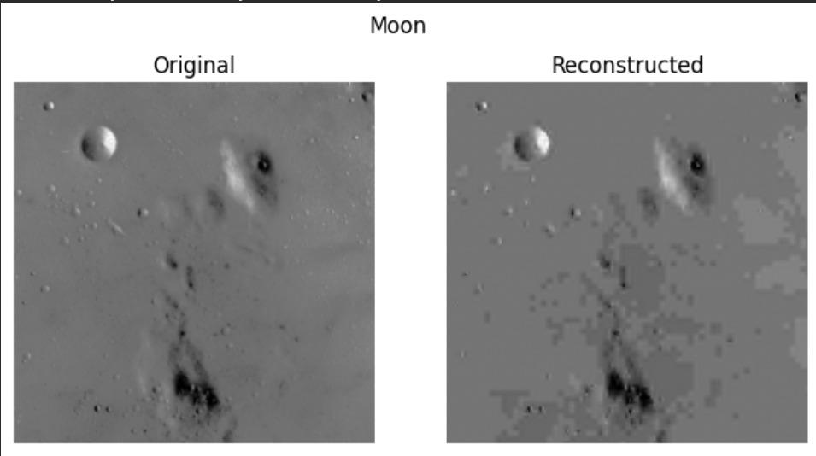
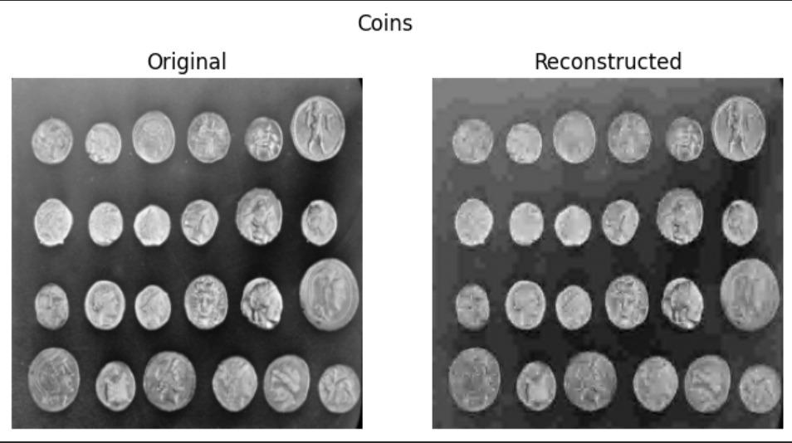
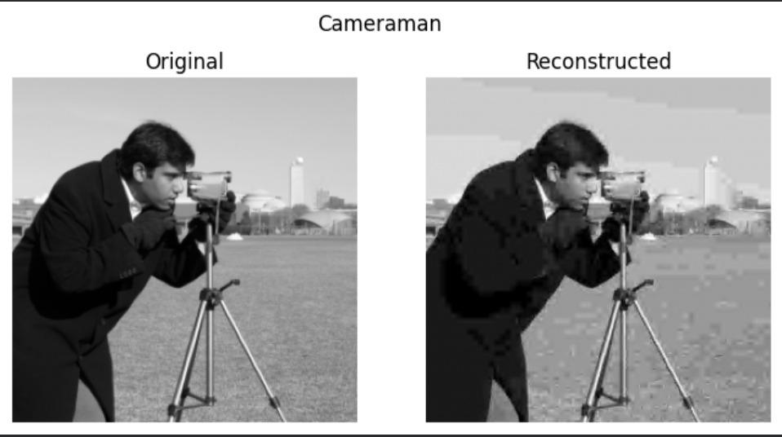

VIII. Conclusion

This paper presents a hybrid wavelet-based image compression framework that integrates DWT, Bayesian thresholding, variance-based adaptive quantization, and Run-Length Encoding. By aligning compression strategies with statistical properties of wavelet coefficients, the proposed method effectively balances compression efficiency and perceptual quality.
The inclusion of adaptive step-size selection further enhances performance by optimizing the rate–distortion trade-off. Experimental results demonstrate that the proposed approach is a promising alternative to traditional compression methods.

